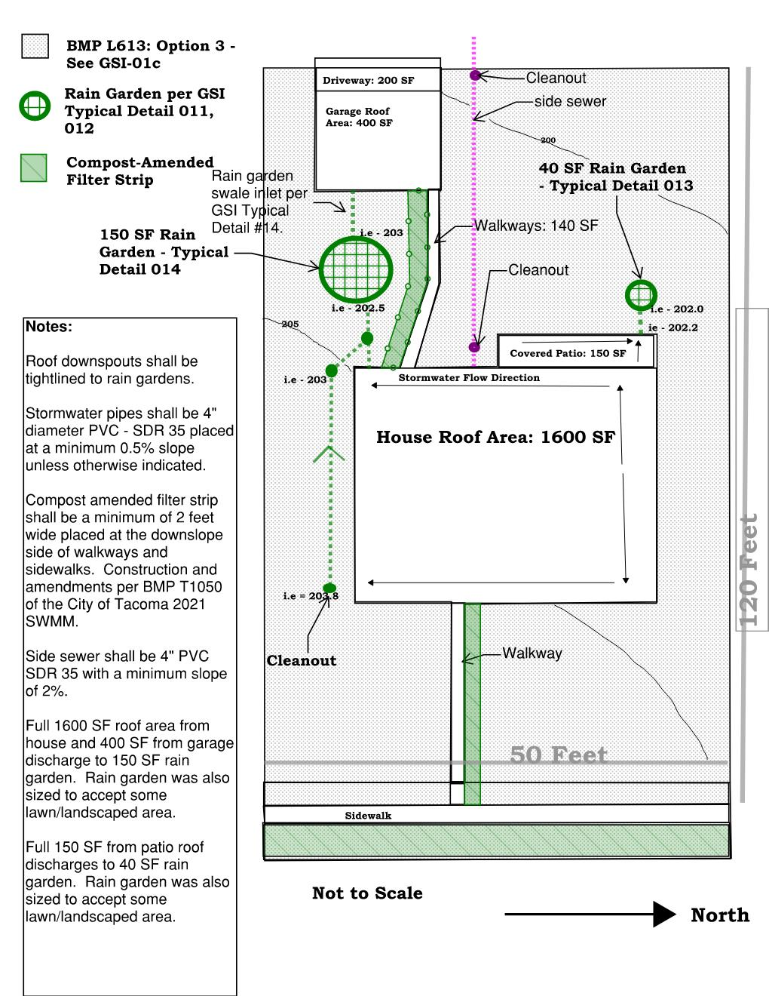

Combined Stormwater Site Plan (SSP) and Construction Stormwater Pollution Prevention Plan Report Short Form
John Q. Family Single Family Home

Prepared For
SDEV21-001Z
Project Location
6816 S. Alder
4940000270

Stormwater Site Plan Prepared By
Name | Organization | Contact Telephone Number | Email Address
Alice B. Contractor | ABC Contracting | 123456789 | abc@abc.com

Date Prepared
06/01/2021

(Insert Professional Engineer Certification and Stamp, if necessary).

Notes for Preparer:
When completing the Combined Stormwater Site Plan (SSP) and Construction Stormwater Pollution Prevention Plan Report Short Form provide all required information in the textbox forms under each section and delete any sections from the report and appendices that are not applicable to the proposed project. Further information and guidance on the information required can be found in the comment bubbles to the right of each section. Once the report has been completed delete all comment bubbles and grey highlighted instructions.

Project Information
- Project Contacts
See Title Page for Stormwater Site Plan Development Team

- Property Owner
Name | Organization | Mailing Address | Contact Telephone Number | Email Address
Alder Pine | None | 1412 S. Ash | 123456897 | alderp@ash.com

- Applicant (if different than Property Owner)
Name | Organization | Mailing Address | Contact Telephone Number | Email Address
(Insert Name) | (Insert Name) | (Insert Address) | (Insert Phone Number) | (Insert Email Address)

- Associated Permits
- See title page for City of Tacoma permit number
- Associated City of Tacoma Permit Number(s)
BLDRN21-0005X, LU20-001V
- Other Federal, State, or Local Associated Permit Types and Numbers
None

- Vesting
- City of Tacoma Stormwater Management Manual Edition Used
2021 Stormwater Management Manual (SWMM)
- If using a manual other than the most current version, provide vesting justification:
NA

Project Overview

- Provide a brief description of the proposed project.
The project proposes to construct a single family home at 6816 S. Alder.

Existing Project Site Conditions

- Answer the following questions, provide additional description, and provide figures (if necessary) to describe the existing site conditions.
- Describe in one or two sentences the existing project site use:
The existing project site is a single family lot covered with patchy grass.

- Describe in words or show on a figure the stormwater runoff patterns (natural and artificial) and the points where stormwater enters and exits the project site.
Stormwater generally flows from southeast to northwest but the site is generally very flat.

- Answer the following questions to help describe the existing site conditions. If Answer is Yes, include an associated figure(s) that shows location. Answers must be based upon site reconnaissance and readily available mapping data. See SWMM – Volume 2, Chapter 3 for resources.

Questions | Answer
Are groundwater protection areas located on the project site or within 500 feet of the project site? | ☒Yes  ☐No  ☐Unknown
Are wetlands and/or their buffers located on the project site or within 500 feet of the project site? | ☐Yes  ☒No  ☐Unknown
Are steep slopes located on the project site or within 500 feet of the project site? | ☐Yes  ☒No  ☐Unknown
Are floodplains located on the project site or within 500 feet of the project site? | ☐Yes  ☒No  ☐Unknown
Are streams located on the project site or within 500 feet of the project site? | ☐Yes  ☒No  ☐Unknown
Are creeks located on the project site or within 500 feet of the project site? | ☐Yes  ☒No  ☐Unknown
Are ravines located on the project site or within 500 feet of the project site? | ☐Yes  ☒No  ☐Unknown
Are springs located on the project site or within 500 feet of the project site? | ☐Yes  ☒No  ☐Unknown
Are any other sensitive areas or critical areas located on the project site or within 500 feet of the project site? | ☐Yes  ☒No  ☐Unknown
Are any structures located on the project site? | ☐Yes  ☒No  ☐Unknown
Are any fuel tanks or other storage tanks (above or below-ground) located on the project site? | ☐Yes  ☒No  ☐Unknown
Are any groundwater wells located on the project site or within 100 feet of the project site? | ☐Yes  ☒No  ☐Unknown
Are any septic systems located on the project site or within 100 feet of the project site? | ☐Yes  ☒No  ☐Unknown
Are any Superfund sites located on the project site or within 100 feet of the project site? | ☐Yes  ☒No  ☐Unknown
Are any Flood Hazard Areas located on the project site or within 100 feet of the project site? | ☐Yes  ☒No  ☐Unknown
Is the project located in the South Tacoma Groundwater Protection District? | ☒Yes  ☐No  ☐Unknown
Are any public or private easements located on the project site? | ☐Yes  ☒No  ☐Unknown

- Additional Information
On Existing Project Site Conditions Map below: the white box with red dot represents the project site. The grey dots show the South Tacoma Groundwater Protection District and the Pink Line Hatch is the Aquifer Recharge Layer. Wastewater lines (red) and stormwater lines (green) are also shown.
Insert associated figure(s) (if applicable) below.

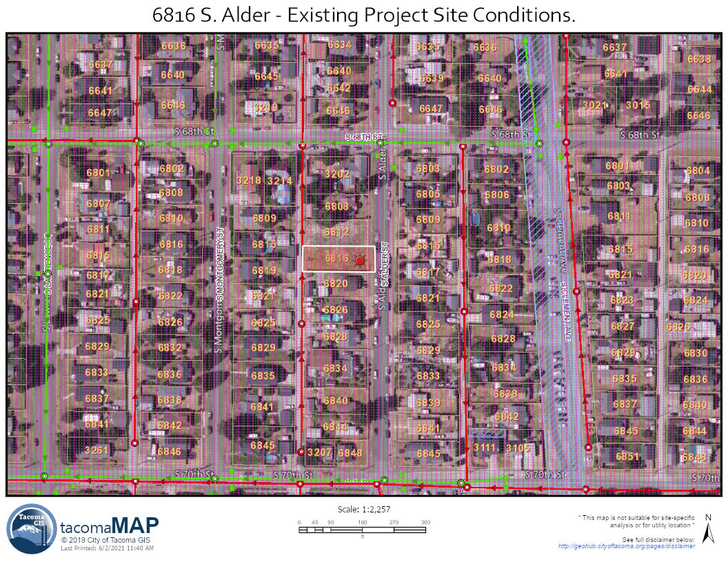
Figure 1 - Existing Project Site Conditions

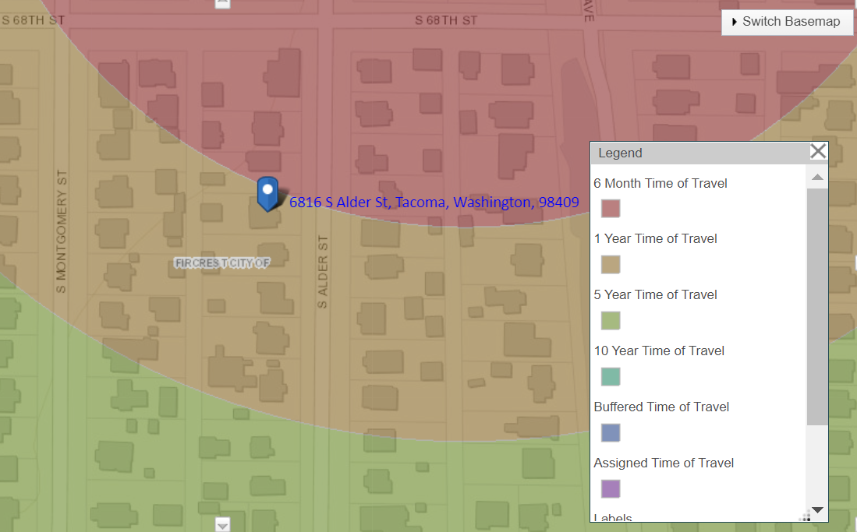
Figure 2 - Groundwater Well - Source Water Assessment Program

B. Existing Project Site Condition Basin Map
- Provide an existing conditions basin map
Provide a current aerial of the project site to show the existing site conditions. Aerial image must show the extent of existing hard surface areas, vegetation areas, pasture areas, and lawn/landscaped areas. Include a scale.

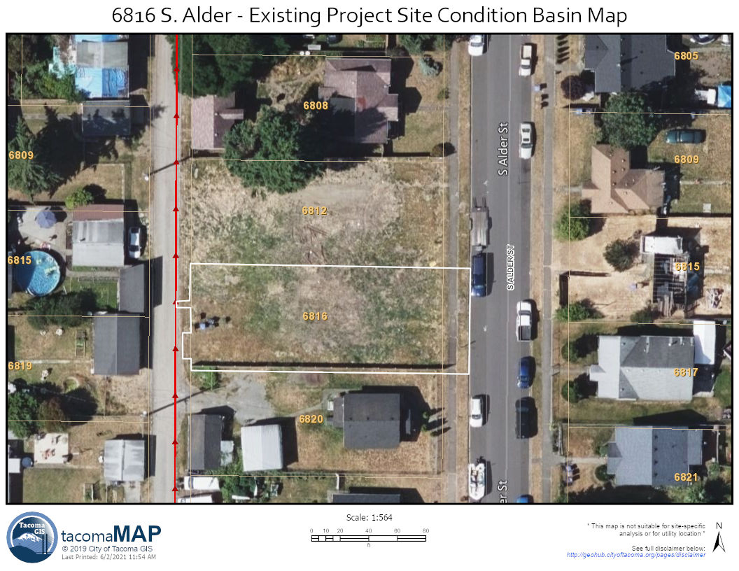
Figure 3 - Existing Project Site Condition Basin Map

C. Downstream Flowpath

Provide a map showing the downstream flowpath from the project site to the Puget Sound – including all receiving waterbodies along the flowpath. Assume that stormwater does not infiltrate along the flowpath and will ultimately reach the Puget Sound.
Figure 4- Downstream Flowpath
Figure 4 - Downstream Flowpath

Proposed Project Site Conditions

Describe in words and provide figure(s) or drawing(s) that describe the proposed project site conditions.
- Describe in one or two sentences the proposed project site use:
The project proposes to construct a single family home and detached garage with driveway and onsite walkways and associated sidewalks and driveway approach offsite.

- Describe in words or show on a figure the stormwater runoff patterns (natural and artificial) and the points where stormwater enters and exits the project site.

Stormwater flow patterns are generally maintained though most stormwater is now managed onsite.

- Provide a figure showing:
- the proposed improvements (buildings, sidewalks, parking lots, utilities, etc.),
- fuel tanks (above and below ground) that are proposed or will remain in place, proposed groundwater wells on the project site
- proposed septic systems
- proposed public and private easements
Figure 5 – Proposed Project Site Conditions

- Additional Information
(Insert any additional description/information necessary to fully describe existing project site conditions)

Figure 5 - Proposed Project Basin Map

Minimum Requirement Determination

- Project Thresholds
Complete the following project threshold table. Onsite includes any work on the parcel or parcels of land associated with the project. Offsite includes any work within the City Right-of-Way.
Surface Type | Onsite | Offsite | Total of Onsite and Offsite
Proposed Roof Area (ft²) | 1600 | 0 | 1600
Proposed Walkways and Sidewalks (ft²) – includes gravel walkways | 140 | 184 | 324
Proposed Deck/Patio Area (ft²) | 150 | 0 | 150
Proposed Driveway (ft²) | 180 | 20 | 200
Other proposed driving surfaces (parking pads, street improvements, etc.) (ft²) | 0 | 30 | 30
Total Amount of All Proposed Surfaces Above (ft²). (Total proposed hard surface area.) | 2070 | 234 | 2304
Amount of Land Disturbed (ft²) | 6000 | 648 | 6648

- Receiving Waterbody Table
Receiving Waterbody Name | Type of Receiving Waterbody
Flett Creek Holding Basin | Not a receiving waterbody - human made.
Flett Creek | Creek
Chamber's Creek | Creek
Puget Sound | Marine

- Minimum Requirements Required
Applicable Minimum Requirements | Applicable Surface Type Requiring Mitigation
Minimum Requirements #1-5 | New Hard Surfaces
Minimum Requirements #1-5 | Replaced Hard Surfaces
Minimum Requirement #9 | Required for all facilities

- Cumulative Impacts
  - Cumulative Impacts Table
(Complete and Insert Cumulative Impacts Table)
  - Cumulative Impacts Discussion
Construction has not taken place on the parcel since before 2003. The last construction appears to be from the 1950s.

- Flowcharts
(Insert all applicable flowcharts as figures for determining minimum requirements)
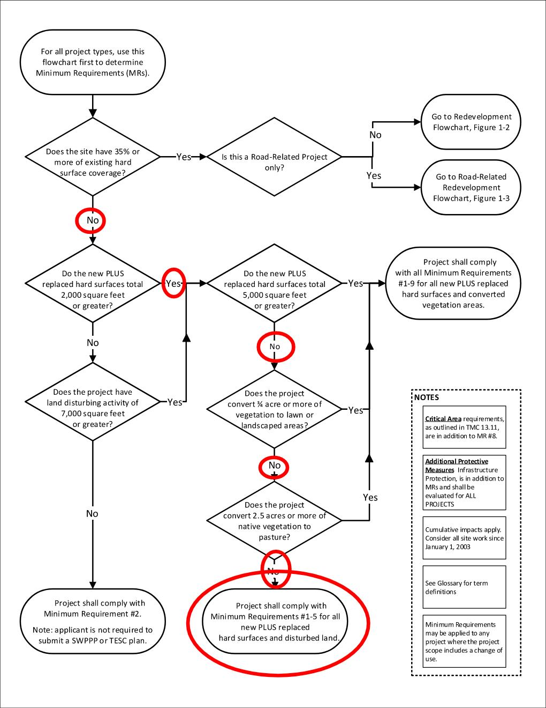

Discussion of Minimum Requirements

Minimum Requirement #1 – Preparation of a Stormwater Site Plan
This Stormwater Site Plan Report and the associated Site Plans and Building Permit Drawings 6816 S. Alder Site Plan and Building Plans are being used to meet Minimum Requirement #1.
Description of Site Appropriate Development Principles
Where practicable, projects shall use the following site appropriate development principles. Put a checkmark next to the principles that will be used for the project. Project design is not required to be changed in order to accommodate site appropriate development principles, but where feasible, these principles must be used. If none of the site development principles are feasible, place a checkmark next to that box below.
☐ Minimization of land disturbance by fitting development to the natural terrain.
☐ Minimization of land disturbance by confining construction to the smallest area feasible and away from critical areas.
☐ Preservation of natural vegetation.
☐ Locating impervious surfaces over less permeable soils.
☐ Clustering buildings.
☐ Minimizing impervious surfaces.
☒ Site appropriate development principles are not practicable because of project design.

Minimum Requirement #2 – Construction Stormwater Pollution Prevention Plan
The Construction Stormwater Pollution Prevention Plan is available in this document before the appendices.

Minimum Requirement #3 – Source Control
- Description of Final Site Use
The final site will be a single family home with detached garage and associated onsite and offsite improvements.
- Source Control BMPs
Select appropriate check box. If project concerns commercial or industrial facilities, insert Source Control Selection Worksheet that describes the types of activities and potential pollutants that are likely to occur on the site and includes the BMPs from the SWMM that will be used on the site.

☒ Single Family Residence: The occupant shall comply with BMP S168: BMPs for Homeowners.
☐ Commercial or Industrial Facilities: (Complete and insert Source Control Selection Worksheet which describes the types of activities and potential pollutants that are likely to occur on the site and includes the BMPs from the SWMM that will be used on the site)

Minimum Requirement #4 – Preserving Drainage Patterns and Outfalls
- Description of Drainage Patterns and Outfalls
All boxes should be checked for this Minimum Requirement. If all boxes cannot be checked an Exception or Adjustment to the Minimum Requirement may be required per Volume 1 of the SWMM.

☒ The natural (or existing) drainage patterns are maintained to the maximum extent feasible.
☒ Discharges from the project site occur at the natural (or existing) location to the maximum extent feasible.
☒ Discharge from the project site will not cause adverse impacts to downstream receiving waters and downgradient properties.

Minimum Requirement #5 – Onsite Stormwater Management
- The List Approach.
This project will utilize The List Approach.
The List Approach requires applicants to complete a feasibility analysis of several BMPs. If those BMPs are considered feasible, they must be used. The types of BMPs that must be analyzed (and used when feasible) depends upon the receiving waterbody into which the project first discharges. If that first waterbody is saltwater (i.e. the Puget Sound) or the Puyallup River – the project is discharging into a flow control exempt waterbody. If the project stormwater discharges into any other receiving waterbody before reaching a saltwater body or the Puyallup River that project is not flow control exempt. Complete the table below for each surface type.
If a BMP is considered to be feasible it must be used. Include the applicable completed facility sizing sheet and show the location of the BMP on the plan set.
If a BMP is not considered to be feasible, insert infeasibility checklist below this table.
Surface Type: Roofs
Not Flow Control Exempt |  | Flow Control Exempt
Analyze Each BMP in the order listed below. Where there is more than one BMP listed, put a checkmark next to the one analyzed. If a BMP is feasible, that BMP must be used and it is not necessary to analyze other BMPs for feasibility. | Is BMP Feasible? | Analyze each BMP in the order listed below. If a BMP is feasible, that BMP must be used and it is not necessary to analyze other BMPs for feasibility. | Is BMP Feasible?
- Choose One:  ☒ BMP L614: Full Dispersion or  ☐ BMP L602: Downspout Full Infiltration | ☐ Yes  ☒ No | - BMP L602: Downspout Full Infiltration | ☐ Yes  ☐ No
- Choose One:  ☒ BMP L601: Rain Gardens or  ☐ BMP L630: Bioretention | ☒ Yes  ☐ No | - BMP L603: Downspout Dispersion | ☐ Yes  ☐ No
- BMP L603: Downspout Dispersion | ☐ Yes  ☐ No | - BMP L604: Perforated Stub-Out Connections | ☐ Yes  ☐ No
- BMP L604: Perforated Stub-Out Connection | ☐ Yes  ☐ No
Surface Type: Other Hard Surfaces
Not Flow Control Exempt |  | Flow Control Exempt
Analyze Each BMP in the order listed below. Where there is more than one BMP listed, put a checkmark next to the one analyzed. If a BMP is feasible, that BMP must be used and it is not necessary to analyze other BMPs for feasibility. | Is BMP Feasible? | Analyze Each BMP in the order listed below. Where there is more than one BMP listed, put a checkmark next to the one analyzed. If a BMP is feasible, that BMP must be used and it is not necessary to analyze other BMPs for feasibility. | Is BMP Feasible?
- BMP L614: Full Dispersion | ☐ Yes  ☒ No | - Choose One:  ☐ BMP L612: Sheet Flow Dispersion, or  ☐ BMP L611: Concentrated Flow Dispersion | ☐ Yes  ☐ No
- Choose One:  ☐ BMP L633: Permeable Pavement, or  ☒ BMP T1050: Compost-Amended Vegetated Filter Strip (CAVFS), or  ☐ BMP L601: Rain Gardens, or  ☐ BMP L630: Bioretention | ☒ Yes  ☐ No
- Choose One:  ☐ BMP L612: Sheet Flow Dispersion, or  ☐ BMP L611: Concentrated Flow Dispersion | ☐ Yes  ☐ No
Surface Type: Lawn/Landscaped Areas
Not Flow Control Exempt |  | Flow Control Exempt
Analyze the BMP below for feasibility. If the BMP is feasible if must be used. | Is BMP Feasible? | Analyze the BMP below for feasibility. If the BMP is feasible if must be used. | Is BMP Feasible?
BMP L613: Post-Construction Soil Quality and Depth | ☒ Yes  ☐ No | BMP L613: Post-Construction Soil Quality and Depth | ☐ Yes  ☐ No

A rain garden will be used for the roof areas of both the garage and the house and the covered patio area.
Compost-Amended filter strips will be used for all walkways and sidewalks.
Onsite stormwater management BMPs are not feasible for the driveway and driveway approach.

- Minimum Requirement #5 – Infeasibility Checklists and BMP Sizing Sheets
Insert completed Infeasibility Checklists and Sizing Sheets directly below before Section F.
City of Tacoma Stormwater Management Manual – Infeasibility Checklist
Surface Type: Roofs and Other Hard Surfaces
BMP L614: Full Dispersion
Version: 07/01/2021
It is not necessary to answer all questions when determining if a BMP is feasible for Minimum Requirement #5 – The List Approach. Unless otherwise noted, a single answer of No means the BMP is considered infeasible for meeting Minimum Requirement #5 – The List Approach. Applicant may choose which questions to answer when determining feasibility.
Questions #1-9 relate to infeasibility criteria that are based on conditions such as topography and distances to predetermined boundaries and certain design criteria.
Question Number | Question | Yes | No | NA
1 | Can the flow spreader and dispersion areas be placed 10 feet or more from any building structure? | ☐ | ☐ | ☐
2 | Can the flow spreader and dispersion areas be placed 5 feet or more from any other structure or property line? | ☐ | ☐ | ☐
3 | Can the dispersion areas be placed 50 feet or more from the top of any slope 15% or greater? | ☐ | ☐ | ☐
4 | Can the dispersion areas be placed 50 feet or more from geologically hazardous areas? | ☐ | ☐ | ☐
5 | Can the dispersion area be located outside of critical areas, critical area buffers, streams, or lakes? | ☐ | ☐ | ☐
6 | Can the flow spreader and dispersion area maintain setbacks from Onsite Sewage Systems per WAC 246-272A-0210? | ☐ | ☐ | ☐
8 | Will installing a full dispersion system cause conflicts with any of the following? (An answer of yes means this BMP is infeasible.) Place a checkmark next to the applicable item (8a-8e). | ☐ | ☐ | ☐
8a | Requirements of the Historic Preservation Laws and Archeology Laws, Federal Superfund or Washington State Model Toxics Control Act, Federal Aviation Administration requirements for airports, or Americans with Disability Act | ☐
8b | Special zoning district design criteria adopted and being implemented through any City of Tacoma planning efforts | ☐
8c | Public health and safety standards | ☐
8d | Transportation regulations to maintain the option for future expansion or multi-modal use of public rights-of-way | ☐
8e | Critical Area Preservation Ordinance | ☐
9 | Can the design standards in BMP L614 be met? | ☐ | ☒ | ☐
9a | Describe the design standard that cannot be met: The project is greater than 10% impervious area.
Questions #10 require evaluation of site specific conditions and a written recommendation from an appropriate Washington State Licensed Professional (e.g., Professional Engineer, Professional Geologist, Professional Hydrogeologist).
10 | Will the use of a full dispersion cause erosion or flooding problems onsite or on adjacent properties? (An answer of yes means this BMP is not feasible). | ☐ | ☐ | ☐

Rain Garden Sizing – Garage and House:
BMP L601 - Rain Garden Sizing Sheet for Minimum Requirement #5 – The List Approach
The top of the ponded surface area below the overflow shall be at least 5% of the total hard surface area draining to the rain garden. The table below provides rain garden geometry based upon contributing area. Rain gardens shall be designed in accordance with the SWMM and the applicable Green Stormwater Infrastructure Typical Detail Figures 011 – 016.

Side Slope | Contributing Area (ft²) | Minimum Top of Ponding Area (ft²) | Minimum Bottom of Ponding Area (ft²) | Minimum Top of Berm Area (ft²)
2:1 | 800 or less | 40 | 0.11 | 50
2:1 | 1400 or less | 70 | 0.13 | 110
3:1 | 3000 or less | 150 | 0.06 | 235

- Roof Area Requiring Mitigation (ft²): 2000
- Total Contributing Area (ft²): 2500
- Minimum Top of Ponded Surface Area: 125

$$Top of Ponded Surface Area (sf)=\left(contributing area (sf)\right)*(0.05)$$

Project will use table with top ponding area of 150 square feet and 3:1 side slopes for the house and garage roof areas.
Rain Garden Sizing – Patio:
BMP L601 - Rain Garden Sizing Sheet for Minimum Requirement #5 – The List Approach
The top of the ponded surface area below the overflow shall be at least 5% of the total hard surface area draining to the rain garden. The table below provides rain garden geometry based upon contributing area. Rain gardens shall be designed in accordance with the SWMM and the applicable Green Stormwater Infrastructure Typical Detail Figures 011 – 016.

Side Slope | Contributing Area (ft²) | Minimum Top of Ponding Area (ft²) | Minimum Bottom of Ponding Area (ft²) | Minimum Top of Berm Area (ft²)
2:1 | 800 or less | 40 | 0.11 | 50
2:1 | 1400 or less | 70 | 0.13 | 110
3:1 | 3000 or less | 150 | 0.06 | 235

- Roof Area Requiring Mitigation (ft²): 150
- Total Contributing Area (ft²): 700
- Minimum Top of Ponded Surface Area: 35

$$Top of Ponded Surface Area (sf)=\left(contributing area (sf)\right)*(0.05)$$

Project will use table with top ponding area of 35 square feet with 2:1 side slopes.

Compost Amended Vegetated Filter Strip Sizing:
BMP T1050– Compost Amended Vegetated Filter Strip (CAVFS) Sizing Sheet for Minimum Requirement #5 – The List Approach
CAVFS shall be designed in accordance with the SWMM.
For sidewalks, walkways, and trails less than 10 feet and where the measured soil infiltration rate is 0.3 inches/hour or greater:
Sidewalk, walkway, trail hard surface width | CAVFS Minimum Width
Less than 6 feet | 2 feet
6 feet to 8 feet | 2.5 feet
8 feet to less than 10 feet | 3 feet

- Sidewalk, walkway, or trail width: 4
- CAVFS Minimum Width: 2

For sidewalks, walkways, and trails greater than 10 feet or where the measured soil infiltration rate is less than 0.3 inches/hour, this sizing sheet cannot be used – a Washington State Professional Engineer must size the facility.
Project will use 2 foot minimum CAVFS widths downslope of all walkways and sidewalks.

Minimum Requirement #6 – Stormwater Treatment
- Description of Compliance Need
Minimum Requirement #6 is not required for this project because the project adds less than 5,000 square feet of new hard surface, converts less than ¾ acre of vegetation to lawn or landscape, and converts less than 2.5 acres of native vegetation to pasture.

Minimum Requirement #7 – Flow Control
- Description of Compliance Need
Minimum Requirement #7 is not required for this project because the project adds less than 5,000 square feet of new hard surface, converts less than ¾ acre of vegetation to lawn or landscape, and converts less than 2.5 acres of native vegetation to pasture.

Minimum Requirement #8 – Wetlands Protection
- Description of Compliance Need
Minimum Requirement #8 is not required for this project because the project adds less than 5,000 square feet of new hard surface, converts less than ¾ acre of vegetation to lawn or landscape, and converts less than 2.5 acres of native vegetation to pasture.

Minimum Requirement #9 – Operation and Maintenance
Pick the statement or statements below that apply to this project.
☐ This project does not propose to install any permanent stormwater facilities. An Operation and Maintenance Manual is not required.
☒ The Operation and Maintenance Manual is available as a stand-alone document as part of the Permit submittal.
☐ For facilities to be maintained by the City of Tacoma (facilities located in the City Right-of-Way designed to manage stormwater from the City Right-of-Way) include the following language: The City of Tacoma is responsible for creating and keeping an Operation and Maintenance Manual for all facilities to be maintained by the City of Tacoma.

Additional Protective Measure – Infrastructure Protection

- Description of Compliance Need
A quantitative downstream analysis is not required because the project is not increasing the surface area contributing to the downstream system by 5,000 square feet or more and is not increasing the surface area converted from pervious to impervious contributing to the downstream system by 5,000 square feet or more.

Conveyance System Design – Collect and Covey

Onsite collection of stormwater and conveyance to the City of Tacoma stormwater system may be necessary if onsite stormwater management BMPs cannot fully infiltrate or disperse stormwater onsite. This may include conveyance to either the curb and gutter or wedge curb, if present, or a structure of the stormwater conveyance system. Connections directly to the pipes are not allowed. Stormwater runoff shall not be conveyed over driveways, sidewalks, or other areas reserved for pedestrian traffic.
All connections shall comply with Volume 5, Chapter 4 of the SWMM.
Connections to the curb and gutter or asphalt wedge curb shall comply with City of Tacoma Standard Plans SU-29 and SU-29a. The minimum pipe size for conveyance to the curb shall be 3” in diameter. Where capacity greater than 3” is required, storm main extension may be required.
Answer the following questions to determine if onsite collection of stormwater and conveyance to the curb is allowed. If any question has an answer of No, extension of the City stormwater system or on-site management is necessary. Extension of the City stormwater system requires a separate Work Order Permit.
Question | Yes | No
Is a catch basin or other inlet to the conveyance system located within 350 feet downstream of the discharge location? | ☐ | ☐
Can stormwater from the project site remain in the gutter line to the nearest stormwater inlet (ie, is there curb and gutter or asphalt wedge curb all the way to an inlet)? | ☐ | ☐
If that gutter line at least 3” tall all the way to the downstream inlet? | ☐ | ☐
Can stormwater from the project site enter a stormwater inlet before the next downstream intersection? | ☐ | ☐
Can stormwater be discharged on the low side of a full warp street section? | ☐ | ☐
Construction Stormwater Pollution Prevention Plan (SWPPP) Report

Erosion and Sediment Control Lead
Name | Organization | Contact Telephone Number | Email Address | CESCL/CPESC Number (if applicable)
A. Contractor | Contracting Inc. | 234567891 | build@build.build | NA

Proposed Construction Schedule
- Proposed Start Date: June 2021

- Proposed End Date: November 2021

- Describe proposed phasing or sequencing (if any): No proposed phasing.

13 Elements of Construction Stormwater Pollution Prevention
Below the 13 Elements of Construction Stormwater Pollution Prevention are provided. For each element, place a checkmark next to the BMP that will be used to satisfy the element. If Other is checked describe how the element will be addressed in detail. If an element is not required, justification for why that element is not required must be included. Volume 3, Table 3-1: Construction Stormwater BMPs by SWPP Element is a guide that can be used to help determine appropriate BMPs to address each Element.

Element #1: Preserve Vegetation and Mark Clearing Limits
- Before beginning any land disturbing activities, including clearing and grading, clearly mark all clearing limits, sensitive areas and their buffers, and trees that are to be preserved within the construction area to prevent damage and offsite impacts. Mark clearing limits both in the field and on the plans.
- Retain the duff layer, native topsoil, and natural vegetation in an undisturbed state to the maximum degree practicable. If it is not practicable to retain the duff layer in place, stockpile it onsite, cover it to prevent erosion, and replace it immediately upon completion of the ground-disturbing activities.
- Plastic, metal, fabric fence, or other physical barriers may be used to mark the clearing limits.
The BMP(s) proposed to meet this element are:
☐ BMP C101: Preserving Natural Vegetation
☐ BMP C102: Buffer Zone
☒ BMP C103: High Visibility Fence
☐ Other: (Insert description of how element will be addressed)
☐ This Element is not required for this project because: (Insert justification as to why Element is not required)

Element #2: Establish Construction Access
- Limit construction vehicle ingress and egress to one route, if possible.
- Stabilize access points with a pad of quarry spalls, crushed rock, or other equivalent BMPs to minimize tracking of sediment.
- Locate wheel wash or tire baths onsite if other measures fail to control sediment from leaving the site.
- No tracking of sediment offsite is allowed. If sediment is tracked offsite, offsite areas (including roadways) shall be thoroughly and immediately cleaned by shoveling or pickup sweeping. Transport sediment to a controlled sediment disposal area.
- Keep streets clean at ALL times. Clean tracked sediment immediately.
- Washing of sediment to the stormwater system is not allowed.
The BMP(s) proposed to meet this element are:
☒ BMP C105: Stabilized Construction Entrance
☐ BMP C106: Wheel Wash
☐ BMP C107: Construction Road/Parking Area Stabilization
☐ Other: (Insert description of how element will be addressed)
☐ This Element is not required for this project because: (Insert justification as to why Element is not required)

Element #3: Control Flow Rates
- Protect downstream properties, receiving waters, and conveyance systems from erosion and other damage due to increases in the velocity and peak volumetric flowrate of stormwater from the project site. A quantitative downstream analysis may be required to ensure no damage to the downstream conveyance system during construction. See Additional Protective Measure - Infrastructure Protection.
- Where necessary, construct flow control facilities as one of the first steps in grading.
- Flow control facilities shall be functional prior to construction of site improvements (e.g. impervious surfaces). It may be necessary to install temporary flow control facilities to meet flow control requirements during construction.
- Control structures designed for permanent flow control BMPs are not appropriate for use during construction without modification. If used during construction, modify the control structure to allow for long-term storage of runoff and enable sediments to settle. Verify that the BMP is sized appropriately for this purpose. Restore BMPs to their original design dimensions, remove sediment, and install a final control structure at completion of the project.
- Velocity of water leaving the site shall not exceed 3 feet/second if the discharge is to a stream or ditch.
- Permanent infiltration facilities shall not be used for flow control during construction unless lined. The bottom of the facility shall be scarified to ensure any compaction that occurred during construction is mitigated.
The BMP(s) proposed to meet this element are:
☐ BMP C203: Water Bars
☐ BMP C207: Check Dams
☐ BMP C209: Outlet Protection
☒ BMP C235: Wattles
☐ BMP C240: Sediment Trap
☐ BMP C241: Temporary Sediment Pond
☐ Other: (Insert description of how element will be addressed)
☐ This Element is not required for this project because: (Insert justification as to why Element is not required)

Element #4: Install Sediment Controls
- Design, install, and maintain effective erosion controls and sediment control to minimize the discharge of pollutants.
- Minimize sediment discharges from the site. The design, installation and maintenance of erosion and sediment controls must address factors such as the amount, frequency, intensity and duration of precipitation, the nature of resulting stormwater, and soil characteristics, including the range of soil particle sizes expected to be present on the site.
- Prior to leaving a construction site or prior to discharge to an infiltration facility, stormwater from disturbed areas shall pass through a sediment removal BMP.
- Construct sediment control BMPs as one of the first steps in grading. These BMPs shall be functional before other land disturbing activities take place.
- Locate BMPs in a manner to avoid interference with the movement of juvenile salmonids attempting to enter off-channel areas or conveyance channels.
- Provide and maintain natural buffers around surface waters, direct stormwater to vegetated areas to increase sediment removal and maximize infiltration, where feasible.
- Seed and mulch earthen structures such as dams, dikes, and diversions according to the timing indicated in Element #5.
- Design outlet structures to withdraw impounded stormwater from the surface to avoid discharging sediment that is still suspended lower in the water column. If installing a floating pump structure, include a stopper to prevent the pump basket from hitting the bottom of the pond.
- Full stabilization includes concrete or asphalt paving; quarry spalls used as ditch lining; or the use of rolled erosion products, a bonded fiber matrix product, or vegetative cover in a manner that will fully prevent soil erosion.
The BMP(s) proposed to meet this element are:
☐ BMP C231: Brush Barrier
☐ BMP C232: Gravel Filter
☐ BMP C233: Silt Fence
☐ BMP C234: Vegetated Filter Strip
☒ BMP C235: Wattles
☐ BMP C240: Sediment Trap
☐ BMP C241: Temporary Sediment Pond
☐ BMP C250: Construction Stormwater Chemical Treatment
☐ Other: (Insert description of how element will be addressed)
☐ This Element is not required for this project because: (Insert justification as to why Element is not required)

Element #5: Stabilize Soils
- Stabilize exposed and unworked soils by application of effective BMPs that prevent erosion.
- From October 1 through April 30, no soils shall remain exposed and unworked for more than 2 days. From May 1 to September 30, no soils shall remain exposed and unworked for more than 7 days. This stabilization requirement applies to all soils onsite, whether at final grade or not.
- Stabilize soils at the end of the shift, before a holiday or weekend, if needed, based on the weather forecast.
- Select appropriate soil stabilization measures for the time of year, site conditions, estimated duration of use, and the potential water quality impacts that stabilization agents may have on downstream waters or groundwater.
- Stabilize soil stockpiles from erosion, protect stockpiles with sediment trapping measures, and where possible, locate piles away from stormwater system inlets, waterways, and conveyance channels.
- Control stormwater volume and velocity within the site to minimize soil erosion.
- Control stormwater discharges, including peak volumetric flowrates and total stormwater volume, to minimize erosion at outlets and to minimize downstream channel and stream bank erosion.
- Minimize the amount of soil exposed during construction activity.
- Minimize the disturbance of steep slopes.
- Minimize soil compaction and, unless infeasible, preserve topsoil.
- Ensure the gravel base used for stabilization is clean and does not contain fines or sediment.
The BMP(s) proposed to meet this element are:
☐ BMP C120: Temporary and Permanent Seeding
☒ BMP C121: Mulching
☐ BMP C122: Nets and Blankets
☐ BMP C123: Plastic Covering
☒ BMP C124: Sodding
☐ BMP C125: Compost
☐ BMP C126: Topsoiling
☐ BMP C127: Polyacrylamide for Soil Erosion Protection
☐ BMP C130: Surface Roughening
☐ BMP C131: Gradient Terraces
☒ BMP C140: Dust Control
☐ Other: (Insert description of how element will be addressed)
☐ This Element is not required for this project because: (Insert justification as to why Element is not required)

Element #6: Protect Slopes
- Design and construct cut-and-fill slopes in a manner to minimize erosion. Applicable practices include, but are not limited to, reducing continuous length of slope with terracing and diversions, reducing slope steepness, and roughening slope surfaces (for example, track walking).
- Divert offsite stormwater (sometimes called run-on) or groundwater away from slopes and disturbed areas with interceptor dikes and/or swales. Manage offsite stormwater separately from stormwater generated on the site.
- At the top of the slopes, collect stormwater in pipe slope drains or protected channels to prevent erosion. Size temporary pipe slope drains to convey either:
  - The peak volumetric flowrate calculated using a 10-minute time step from a Type 1A, 10-year, 24-hour frequency storm using a single event model, or
  - The 10-year return period flowrate, indicated by an Ecology-approved continuous simulation model, using a 15-minute time step.
- Use the existing land cover condition for predicting flowrates from tributary areas outside the project limits. For tributary areas on the project site, use the temporary or permanent project land cover condition, whichever will produce the highest flowrate. If using, a continuous simulation model, model bare soils as landscaped areas.
- Provide temporary or permanent conveyance to remove groundwater seepage from the slope surface of exposed soil areas.
- Place excavated material on the uphill side of trenches, consistent with safety and space considerations.
- Place check dams at regular intervals within channels that are cut down a slope.
- Stabilize soils on slopes, as specified in Element #5.
The BMP(s) proposed to meet this element are:
☐ BMP C120: Temporary and Permanent Seeding
☐ BMP C121: Mulching
☐ BMP C122: Nets and Blankets
☐ BMP C123: Plastic Covering
☐ BMP C124: Sodding
☐ BMP C130: Surface Roughening
☐ BMP C131: Gradient Terraces
☐ BMP C200: Interceptor Dike and Swale
☐ BMP C201: Grass-Lined Channels
☐ BMP C203: Water Bars
☐ BMP C204: Pipe Slope Drains
☐ BMP C205: Subsurface Drains
☐ BMP C206: Level Spreader
☐ BMP C207: Check Dams
☐ BMP C208: Triangular Silt Dike (Geotextile-Encased Check Dam)
☐ Other: (Insert description of how element will be addressed)
☒ This Element is not required for this project because: Project site has no slopes to protect.

Element #7: Protect Stormwater System Inlets
- Protect all stormwater system inlets that are operable during construction so that stormwater does not enter the conveyance system without first being filtered or treated to remove sediment.
- Clean or remove and replace inlet protection devices when sediment has filled 1/3 of the available storage (unless a different standard is specified by the product manufacturer).
- Keep all approach roads clean. Do not allow sediment to enter the stormwater system.
- Inspect inlets weekly at a minimum and daily during storm events.
The BMP(s) proposed to meet this element are:
☒ BMP C220: Stormwater System Inlet Protection
☐ Other: (Insert description of how element will be addressed)
☐ This Element is not required for this project because: (Insert justification as to why Element is not required)

Element #8: Stabilize Channels and Outlets
- Design, construct, and stabilize all temporary onsite conveyance channels to prevent erosion from either:
  - The peak volumetric flowrate calculated using a 10-minute time step from a Type 1A, 10-year, 24-hour frequency storm using a single event model, or
  - The 10-year return period flowrate, indicated by an Ecology-approved continuous simulation model, using a 15-minute time step.
- Use the existing land cover condition for predicting flowrates from tributary areas outside the project limits. For tributary areas on the project site, use the temporary or permanent project land cover condition, whichever will produce the highest flowrate. If using a continuous simulation model, model bare soils as landscaped areas.
- Provide stabilization, including armoring material, adequate to prevent erosion of outlets, adjacent stream banks, slopes, and downstream reaches at the outlets of all conveyance systems.
The BMP(s) proposed to meet this element are:
☐ BMP C122: Nets and Blankets
☐ BMP C202: Rip Rap Channel Lining
☐ BMP C207: Check Dams
☐ BMP C209: Outlet Protection
☐ Other: (Insert description of how element will be addressed)
☒ This Element is not required for this project because: Temporary onsite conveyance systems are not proposed.

Element #9: Control Pollutants
- Design, install, implement and maintain effective pollution prevention measures to minimize the discharge of pollutants.
- All discharges to the City of Tacoma wastewater system require City approval. Some discharges to the City of Tacoma stormwater system require City approval. The approval may include a separate Special Approved Discharge (SAD) permit. Visit https://www.cityoftacoma.org/government/city_departments/environmentalservices/wastewater/wastewater_permits_and_manuals for additional information about SAD Permits.
- Handle and dispose of all pollutants, including waste materials and demolition debris that occur on site in a manner that does not cause contamination of stormwater.
- Provide cover, containment, and protection from vandalism for all chemicals, liquid products, petroleum products, and other materials that have the potential to pose a threat to human health and the environment. Provide secondary containment for tanks holding pollutants including onsite fueling tanks. Secondary containment means placing tanks or containers within an impervious structure capable of containing 110% of the volume contained in the largest tank within the containment structure. Double-walled tanks do not require additional secondary containment.
- Conduct maintenance, fueling, and repair of heavy equipment and vehicles using spill prevention and control measures. Clean contaminated surfaces immediately following any spill incident.
- Conduct oil changes, hydraulic system drain down, solvent and degreasing cleaning operations, fuel tank drain down and removal, and other activities, which may result in discharge or spillage of pollutants to the ground or into stormwater using spill prevention measures, such as drip pans.
- Discharge wheel wash or tire bath wastewater to a separate onsite treatment system that prevents discharge to surface water. Alternatively, discharge wheel wash or tire bath wastewater to the wastewater system (only allowed with SAD Permit approval).
- Apply fertilizers and pesticides in a manner and at application rates that will not result in loss of chemicals to stormwater. Follow manufacturers’ recommendations for application rates and procedures.
- Use BMPs to prevent or treat contamination of stormwater by pH modifying sources. These sources include, but are not limited to, recycled concrete stockpiles, bulk cement, cement kiln dust, fly ash, new concrete washing and curing waters, waste streams generated from concrete grinding and sawing, exposed aggregate processes, dewatering concrete vaults, and concrete pumping and mixer washout waters.
- Adjust the pH of stormwater if necessary to prevent violations of water quality standards.
- Manage concrete washout appropriately.
  - Washout concrete truck drums or concrete handling equipment in onsite or offsite designated concrete washout areas only.
    - Do not washout concrete truck drums or concrete handling equipment to streets, the stormwater system, receiving waterbodies, or the ground.
  - Washout of small concrete handling equipment may be disposed of in a formed areas awaiting concrete where it will not contaminate stormwater and surface water or groundwater.
  - Do not use upland land applications for discharging wastewater from concrete washout areas.
  - Do not dump excess concrete onsite, except in designated concrete washout areas.
  - Do not washout anything contaminated with concrete into formed areas awaiting infiltration BMPs.
  - Concrete spillage or concrete discharge directly to groundwater or surface waters of the State is prohibited.
- Written approval from the Department of Ecology is required prior to using chemical treatment other than CO2, dry ice, or food grade vinegar to adjust pH.
- Clean contaminated surfaces immediately following any discharge or spill incident.
- Uncontaminated water from water-only based shaft drilling for construction of building, road, and bridge foundations may be infiltrated provided the wastewater is managed in a way that prohibits discharge to surface waters. Prior to infiltration, water from water-only based shaft drilling that comes into contact with curing concrete must be neutralized until pH is in the range of 6.5 to 8.5.
The BMP(s) proposed to meet this element are:
☒ BMP C151: Concrete Handling
☒ BMP C152: Sawcutting and Surface Pollution Prevention
☒ BMP C153: Material Delivery, Storage and Containment
☒ BMP C154: Concrete Washout Area
☐ BMP C250: Construction Stormwater Chemical Treatment
☐ Other: (Insert description of how element will be addressed)
☐ This Element is not required for this project because: (Insert justification as to why Element is not required)

Element #10: Dewatering
- Dewatering discharges to the City of Tacoma stormwater conveyance system or the City of Tacoma wastewater system may require City approval through a Special Approved Discharge (SAD) Permit. See https://www.cityoftacoma.org/government/city_departments/environmentalservices/wastewater/wastewater_permits_and_manuals for more information on the SAD Permit Process.
- Discharge foundation, vault, and trench dewatering water that has similar characteristics to site stormwater into a controlled conveyance system prior to discharge to a sediment trap or sediment pond. Stabilize channels as specified in Element #8.
- Clean, non-turbid dewatering water, such as well-point groundwater, can be discharged to systems tributary to state surface waters, as specified in Element #8, provided the dewatering flow does not cause erosion or flooding of receiving waters. Do not route clean dewatering water through TESC BMPs.
- Handle highly turbid or contaminated dewatering water separately from stormwater at the site.
- Other disposal options, depending on site constraints, may include:
  - Infiltration
  - Transport offsite in vehicle, such as a vacuum flush truck, for legal disposal in a manner that does not pollute state waters
  - Ecology approved onsite chemical treatment or other suitable treatment technologies
  - Use of a sedimentation bag that discharges to a ditch or swale for small volumes of localized dewatering
The BMP(s) proposed to meet this element are:
☐ BMP C203: Water Bars
☐ BMP C206: Level Spreader
☐ BMP C236: Vegetative Filtration
☐ Other: (Insert description of how element will be addressed)
☒ This Element is not required for this project because: Dewatering is unlikely due to proximity of work to surface.

Element #11: Maintain BMPs
- Maintain and repair as needed all temporary and permanent erosion and sediment control BMPs to assure continued performance of their intended function. Conduct maintenance and repairs in accordance with BMP specifications.
- Remove temporary erosion and sediment control BMPs within 30 days after final site stabilization is achieved or after the temporary BMPs are no longer needed. Trapped sediment shall be removed or stabilized onsite. Permanently stabilize disturbed soil resulting from removal of BMPs or vegetation.
The BMP(s) proposed to meet this element are:
☒ BMP C150: Materials on Hand
☒ BMP C160: Erosion and Sediment Control Lead
☐ BMP C236: Vegetative Filtration
☐ Other: (Insert description of how element will be addressed)
☐ This Element is not required for this project because: (Insert justification as to why Element is not required)

Element #12: Manage the Project
- Phasing of Construction – Phase development projects in order to prevent soil erosion and the transport of sediment from the project site during construction, unless the Erosion and Sediment Control Lead can demonstrate that construction phasing is infeasible. Revegetation of exposed areas and maintenance of that vegetation shall be an integral part of the clearing activities for any phase.
- Seasonal Work Limitations – From October 1 through April 30, clearing, grading, and other soil disturbing activities shall only be permitted if shown to the satisfaction of the City that silt-laden stormwater will be prevented from leaving the site through a combination of the following:
  - Site conditions including existing vegetative coverage, slope, soil type, and proximity to receiving waters;
  - Limitations on activities and the extent of disturbed areas; and
  - Proposed erosion and sediment control measures.
Based on the information provided and local weather conditions, the City may expand or restrict the seasonal limitation onsite disturbance. The following activities are exempt from the seasonal clearing and grading limitations:
  - Routine maintenance and necessary repair of erosion and sediment control BMPs
  - Routine maintenance of public facilities or existing utility structures that do not expose the soil or result in the removal of the vegetative cover to soil
  - Activities where there is one hundred percent infiltration of stormwater within the site in approved and installed erosion and sediment control facilities
- Inspection and Monitoring
- Inspect, maintain, and repair all BMPs as needed to assure continued performance of their intended function. Projects regulated under the Construction Stormwater General Permit (CSWGP) must conduct site inspections and monitoring in accordance with Special Condition S4 of the CSWGP.
- Projects that disturb one or more acres must have site inspections conducted by a Certified Erosion and Sediment Control Lead (CESCL) or Certified Professional in Erosion and Sediment Control (CPESC).
- Projects disturbing less than one acre must have an Erosion Sediment Control Lead (ESC) conduct inspections. The ESC Lead does not have to have CESCL or CPESC certification.
- The CESCL, CPESC, or ESC Lead shall be identified in the SWPPP and shall be onsite or on-call at all times.
- The CESCL, CPESC, or ESC Lead must examine stormwater visually for the presence of suspended sediment, turbidity, discoloration, and oil sheen and evaluate the effectiveness of BMPs to determine if it is necessary to install, maintain, or repair BMPs.
- The CESCL, CPESC, or ESC Lead must inspect all areas disturbed by construction activities, all BMPs, and all locations where stormwater leaves the site at least once every calendar week and within 24 hours of any discharge from the site. (Individual discharge events that last more than one day do not require daily inspections). The CESCL, CPESC, or ESC Lead may reduce the inspection frequency for temporary stabilized, inactive sites to once every calendar month.
- Construction site operators must correct any problems identified by the CESCL, CPESC, or ESC Lead by:
- Reviewing the SWPPP for compliance with the 13 construction SWPPP elements and making appropriate revisions within 7 days of the inspection.
- Fully implementing and maintaining appropriate source control and/or treatment BMPs as soon as possible but correcting the problem within 10 days.
- Documenting BMP implementation and maintenance in the site log book. (Required for sites larger than 1 acre but recommended for all sites).
Sampling and analysis of the stormwater discharges from a construction site may be necessary on a case-by-case basis to ensure compliance with standards. Ecology or the City will establish these monitoring and associated reporting requirements.
- Responsible Party – For all projects, a 24-hour responsible party shall be listed in the SWPPP, along with that person’s telephone number and email address.
- Maintenance of the Construction SWPPP – Keep the Construction SWPPP onsite or within reasonable access to the site. Modify the SWPPP whenever there is a change in the design, construction, operation, or maintenance at the construction site that has, or could have, a significant effect on the discharge of pollutants to waters of the state.
Modify the SWPPP if, during inspections or investigations conducted by the owner/operator, City staff, or by local or state officials, it is determined that the SWPPP is ineffective in eliminating or significantly minimizing pollutants in stormwater discharges from the site. Modify the SWPPP as necessary to include additional or modified BMPs designed to correct problems identified. Complete revisions to the SWPPP within seven (7) days following the inspection. City of Tacoma Environment Services (review staff or inspector) may require that a modification to the SWPPP go through additional City review.
The BMP(s) proposed to meet this element are:
☒ BMP C150: Materials on Hand
☒ BMP C160: Erosion and Sediment Control Lead
☒ BMP C162: Scheduling
☐ Other: (Insert description of how element will be addressed)
☐ This Element is not required for this project because: (Insert justification as to why Element is not required)

Element #13: Protect Permanent Stormwater BMPs
- Protect all permanent stormwater BMPs from sedimentation through installation and maintenance of erosion and sediment control BMPs on portions of the site that drain into the BMPs. Restore all BMPs to their fully functioning condition if they accumulate sediment during construction. Sediment impacting Best Management Practices shall be removed before system start-up. Restoring the BMP shall include removal of all sediment and full replacement of treatment media.
- Prevent compacting infiltration facilities by excluding construction equipment and foot traffic.
- Keep all heavy equipment off native soils under infiltration BMPs that have been excavated to final grade to retain the infiltration rate of the soils.
- Protect lawn and landscaped areas from compaction due to construction equipment and material stockpiles.
- Do not allow muddy construction equipment on the base material of permeable pavement or on the permeable pavement section.
- Do not allow sediment laden runoff onto permeable pavements or base materials of permeable pavements.
- Permeable pavements fouled with sediment or that can no longer pass an initial infiltration test must be cleaned prior to final acceptance.
The BMP(s) proposed to meet this element are:
☐ BMP C102: Buffer Zone
☒ BMP C103: High Visibility Fence
☐ BMP C200: Interceptor Dike and Swale
☐ BMP C201: Grass-Lined Channels
☐ BMP C207: Check Dams
☐ BMP C208: Triangular Silt Dike (Geotextile-Encased Check Dam)
☐ BMP C231: Brush Barrier
☐ BMP C233: Silt Fence
☐ BMP C234: Vegetated Strip
☐ Other: (Insert description of how element will be addressed)
☐ This Element is not required for this project because: (Insert justification as to why Element is not required)

Soils Report

The Soils Report is available as a stand-alone document as part of the Permit submittal. It is titled: New Home Soils Report – March 7, 2021

Operation and Maintenance Manual

The Operation and Maintenance Manual is available as a stand-alone document as part of the Permit submittal. It is titled: 6816 S. Alder Operation and Maintenance Manual

Temporary Erosion and Sediment Control BMPs

Attach below only those BMPs (include the entirety of the BMP language) from Volume 3 of the SWMM that will be utilized onsite.

